Daska Town is locatedat 74o-21’ East and 32o-20’ North at a distance of 24 Km in north- east of Gujranwala City, 24Km from Sialkot at its south-westand 24KM from Wazirabad at its south east .This Town is Tehsil Headquarter of Daska Tehsil falling under the jurisdiction of Sialkot District.

Annual Report
2020-21

Municipal Committee Daska

Table of Contents
Foreword: i
1. Background: 1
1.1 Location 1
1.2 History & Importance 1
1.3 The Climate 1
1.3.1 Weather 1
1.3.2 Rainfall 2
2. Map of Tehsil Daska: 2
3. Functions of Municipal Committee Daska 3
4. Human Resource at MC: 4
4.1. Municipal Corporation Organogram 4
4.2. Administrative Setup 5
4.3. Human resource available at MC 6
3. Covid – 19 (Response & Resilience) 7
4. Anti-Dengue Activities 9
5. Khidmat Apki Dehleez Per 10
3. Clean & Green Punjab Campaign 11
4. Trainings & Hands-on Sessions 12
5. Development Projects under Punjab Cities Program (PCP) 14
5.1. Manpower Deployment 15
6. Municipal Services Delivery Detail 15
6.1. Water supply hours and consumer connections 15
6.2. Tariff rates 15
6.3. Required rehabilitation of the system 16
6.3.1. Repair & Replacements of Pumping machinery for Tube wells 16
6.3.2. Repair of Pump House: 16
6.3.3. Repair of water filtration plants 16
6.4. Solid Waste Management 16
6.4.1. Solid waste Generation & Disposal 17
6.4.2. Equipment & Machinery 17
6.4.3. Manpower Deployed and requirement 17
6.4.4. Existing situation 18
6.4.5. Un-served and Partially Served Areas 18
6.4.6. Solid Waste Generation & Disposal 19
6.5. Sewerage 19
6.5.1. Coverage 19
6.5.2. Drainage zones. 20
6.5.3. Sewer lengths 22
6.6. Streetlight 22
6.6.1. Streetlights on Major roads: 22
6.6.2. Ward wise detail of existing streetlights 22
7. Complaint Management 24
8. MC Website (www.mcDaska.lgpunjab.org.pk) 24
9. MC Response to the Requests of Citizens under RTI Act 2013 25
Annex-A 19

Foreword:

On behalf of the Municipal Committee Daska, I hereby present this Annual Report for the financial year 2020-21. The report will give an insight into the performance and achievements of the Municipal Committee achieved during financial year 2020-21. The current Annual Report outlines MCs successes in relation to our mandate as mentioned in the key focus areas of Local Government Act. This can be summarized as; Building a Municipal Committee that is efficient, effective and responsive; Strengthen Accountability and promote fairness in its dealings; Accelerating Service Delivery and supporting the vulnerable; Promoting Economic and Social development; Fostering Development Partnerships, Social Cohesion and Community Uplift Programs. It is pertinent to note that these endeavors’ can never be successfully achieved on their own but it becomes materialized by the collective efforts of officers, officials and support staff who work together in identifying challenges and to meet those challenges with rigorous efforts and earnest professional approach.

It is commendable to note the improvements in relation to our spending and expenditure patterns, but we need to do more. The ever-present excuse of lack of resources might be a legitimate one, but the key question is how effectively we use the resources at our disposal to accomplish our goals and attaining set targets. It is clear in this annual report that we are moving in the right direction. It is of paramount importance to synchronize our program plans with quarterly targets to achieve our broader goals effectively and efficiently.

Administrator
Municipal Committee
Daska

Background:

Location
Daska Townislocatedat74o-21’ Eastand32o-20’ North at a distance of 24 Km in north- east of Gujranwala City, 24Km from Sialkot at its south-westand 24KM from Wazirabad at its south east .This Town is Tehsil Headquarter of DaskaTehsil falling under the jurisdiction of Sialkot District.

History & Importance
It is an ancient town, and was founded during the reign of the emperor Shah Jehan. According to the revenue record it was originally named Shah Jehanahad, but according to the tradition ,one Mauja ,a Hindu Jat of Mandrianwala village in Daska Tehsil settled at Daska some 500years ago,and it is believed that it spresent name was given to it from the land belonging to the Dasfamily.According to another and more popular account the name has aspecial significance with regard toits location and distance from the important surrounding towns,viz,Gujranwala,Wazirabadand Sialkot.From each of these cities Daska is situated at a distance of daskoh(24kilometers).The actual name due to this significance was originally Das-Koha which later on came to be known as Daska. It is linked with the district head-quarters by two metal led roads which take their course through Ghunike and Sambrial, respectively.

Daska is locally administered by a municipal committee. Because of a bundance of fresh reservoir of sub-soil water ,cultivators hurried up in the installation of tube-wells.This resulted in setting up of cottage industry for the manufacture of diesel engines and accessories. With the availability of electricity the production has shown signs of improvement and is extending rapidly. Arice and grain market has been setup on the outskirts of the town.

The Climate

Weather
The climate of the Town is hot in summer and cool in winter. The summer season starts from April and continues till August while the duration the winter season is from November to February. June is the hottest month .The mean maximum and minimum temperature during the month of June is about 40and25degree Celsius respectively. January is the coldest month. The months of November and March are pleasant.

Rainfall
The average annual rainfall is about 980 millimeters. The highest rainfall is from July to September. Average humidity level is 62%

1.4. Demographic status
A land scan process was done to estimate the population of entire inhabited areas of city in close approximation which was found to be 220,163 persons in the year 2017 with an annual growth rate of 2.65% and it is expected to rise to 284,087 persons in the year 2027. Some inhabitation has developed outside the municipal limits of the city and the municipal limits need to be extended. The population census report of year 2017 has not been published by Government of Pakistan. However the provisional data available for this census shows the population of 231,797 persons for the city within municipal limits.
Economic Activities in the City
The surgical instruments and sports industry has spread towards Daska from Sialkot along Daska-Sialkot road. An industrial corridor along this road has emerged and this industry is earning appreciable foreign exchange. Rice husking and polishing is another industry flourishing around this town and a lot of rice is exported from this Tehsil. The area is irrigated by upper Chenab canal system, enabling cultivation of cash crops and vegetables. Some dairy farming is also developing in the surrounding areas of Daska. Pakistan Agriculture Research Council (PARC), works towards the growth of agriculture and related fields.

Map of Tehsil Daska:

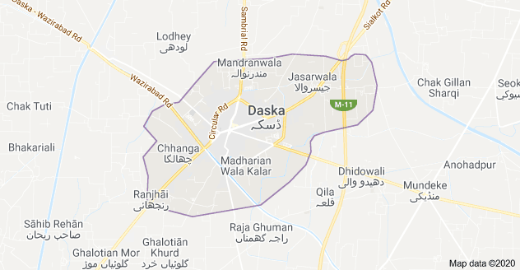

Functions of Municipal Committee Daska
Municipal Committee Daska is responsible for performing the following functions as per new PLGA 2019:
- Economic and value chain development;
- Management of primary, elementary and secondary education facilities;
- School enrolment and universal education;
- Monitoring and supervision of primary health care facilities;
- Preventive health and hygiene;
- Population welfare including population control;
- Solid waste collection and disposal;
- Sewerage collection and disposal including water management and treatment;
- Building control and land use;
- Births, deaths, marriages and divorce registration;
- Museums and art galleries;
- Open markets;
- Livestock and agriculture markets;
- Public parking facilities;
- City roads and traffic management;
- Public transport;
- Abstraction of water for industrial and commercial purposes;
- Emergency planning and relief;
- Support to provincial agencies in prevention of crime and maintenance of public order; and Regulatory enforcement in the functions
- Establishment and management of pre-schools;
- Libraries;
- Drinking water supply;
- Burials, cremations etc.;
- Public conveniences;
- Children's services;
- Community safety;
- Arts and recreation;
- Public fairs and ceremonies;
- Sports;
- Environmental health, awareness and services;
- Parks and landscape development;
- Slaughtering of animals;
- Street lights; and Sign boards and street advertisements.

Human Resource at MC:

Municipal Corporation Organogram

Administrative Setup
Administrator  Mr. Bilal Bin Abdul Hafeez | 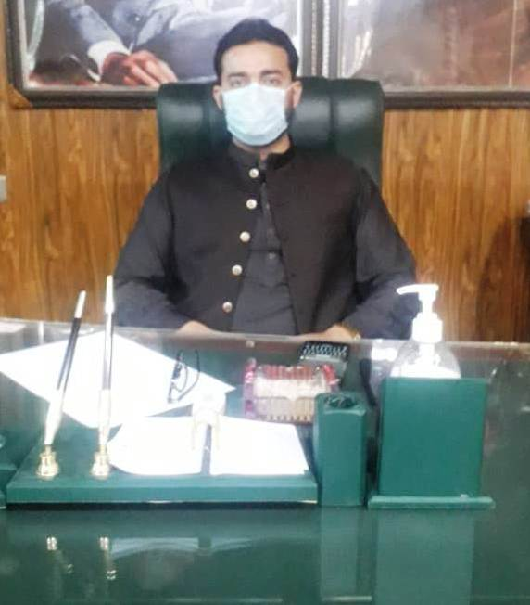
Chief Officer
Muhammad Fayyaz

Municipal Officer (Finance)  Muhammad Usman | 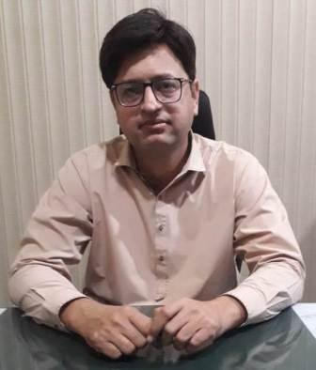
Deputy Municipal Officer  (Infrastructure & Services)  Mian Muhammad Zahid | 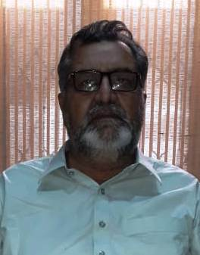
Municipal Officer (Regulation)
Mr. Umair Sultan
Municipal Officer (Planning)
Ms. Maryam Sadeeqa

Human resource available at MC
Vacancy Analysis-Section Wise
Section | Sanctioned | Filled | Vacant
Chairman | 5 | 2 | 3
Chief Officer | 16 | 8 | 8
Municipal officer (R) | 24 | 9 | 15
Municipal officer (I) | 329 | 214 | 115
Municipal officer (P) | 11 | 5 | 6
Municipal Officer (F) | 21 | 8 | 13
Municipal officer (IT) | 3 | 0 | 3
Municipal officer (Archt) | 4 | 0 | 4
Total | 413 | 246 | 167
MC schedule of establishment is attached as Annex-A

Covid – 19 (Response & Resilience)

As early as late 2019, MC management was aware of and beginning to prepare for COVID-19. Administratively, the management began preparing of pandemic plans and connected with other community stakeholders. This helped the city be prepared when we started seeing cases in Daska. As the COVID-19 situation continued to evolve, the city of Daska took precautionary measures to protect both staff and the community against the spread of Coronavirus. In response to the increasing levels of response required to follow the recommendations of health professionals. The city of Daska activated and mobilized its emergency team to curb the pandemic and to avoid as many people from the grip of this disease. By taking emergency measures, the city was able to nimbly respond to the constantly changing environment that COVID-19 presented.

Throughout the pandemic, the city has had three main goals:

- To implement the Standards Operating Procedures (SOPs), protocols and decisions taken by the National Command and Operation Centre (NCOC), Government of Pakistan
- To protect the health and safety of staff throughout the duration of the Pandemic;
- To protect the health and safety of the residents by taking precautionary measures;
- To ensure the provision of critical services to the residents, health care facilities, and businesses.
- To create awareness campaigns and messages to sensitize people, residents and other stakeholders time to time.

City Administration hosted weekly group meetings with the hospital, Augustana, senior’s care providers, and school board officials in order to pool information and share what the municipality was doing. Keeping the public updated through social media, print media and motivational materials was a top priority.

 | 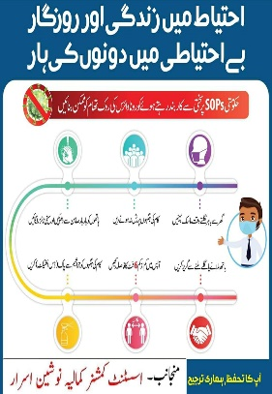
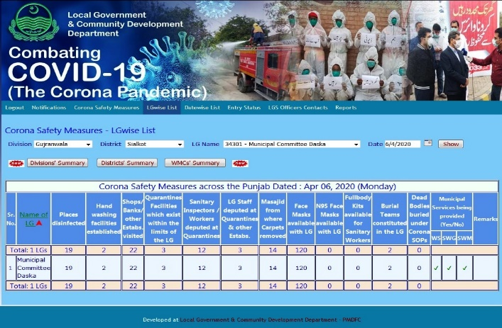 | 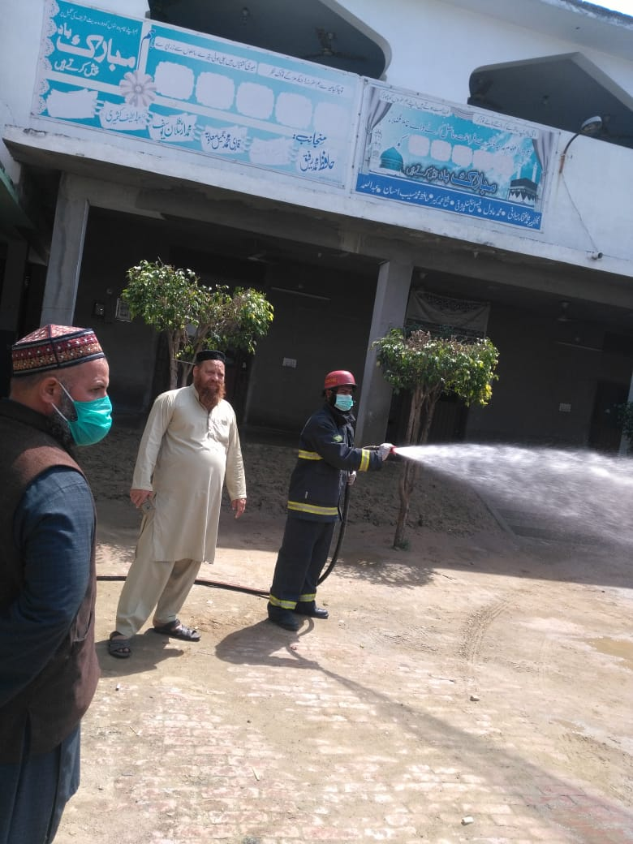
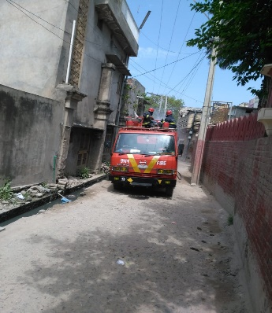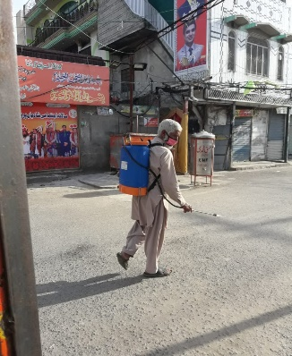 | 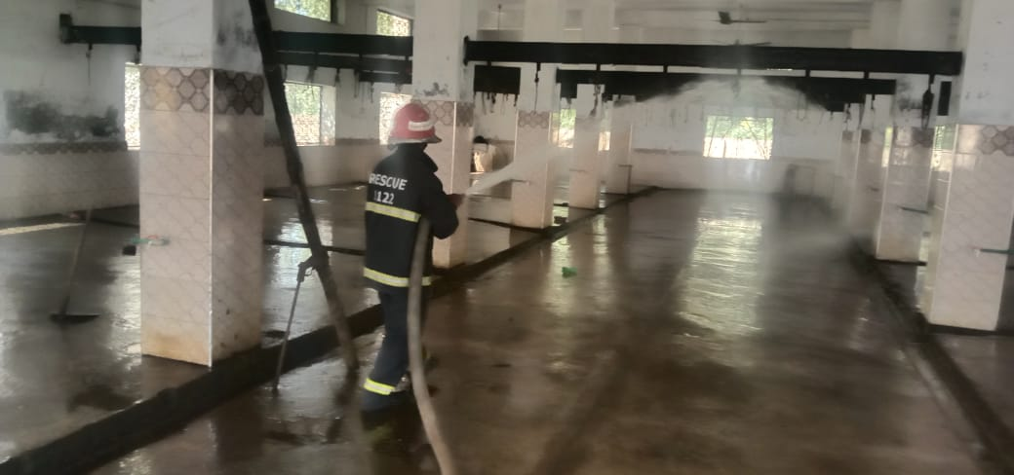
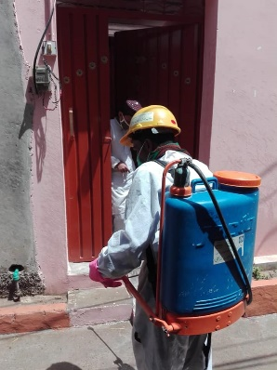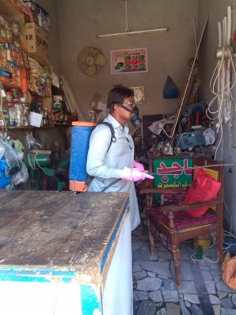 | 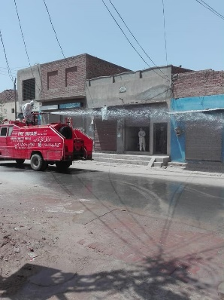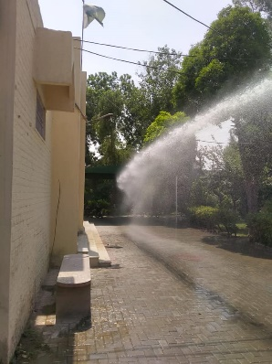
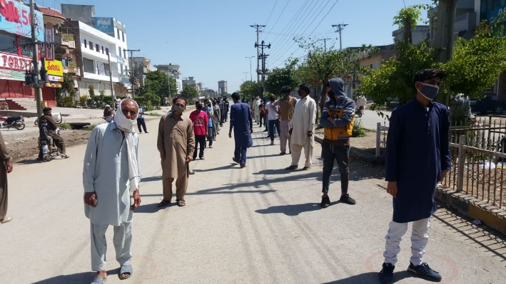 | 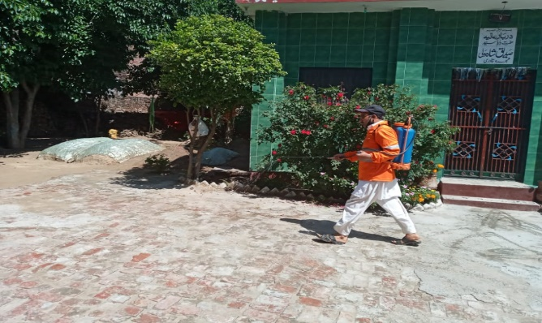

Anti-Dengue Activities

Dengue is a social problem and can be overcome only by including all segments of the society in the anti-dengue drive. By considering need of the hour, MC took steps to create awareness among the people to keep their houses clean and remove stagnant water. MC had been implemented anti-dengue regulations and stern action were imposed on their violators. MC management had given top priority to overcome dengue and special teams had been constituted to keep surveilling high risk areas. In this regard, daily surveillance schedules were prepared, micro plans were developed, field teams were mobilized and social segment of the society were activated to curb the wide spread of epidemic.

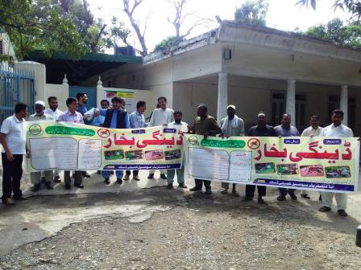 | 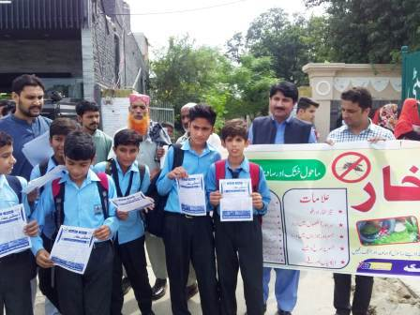
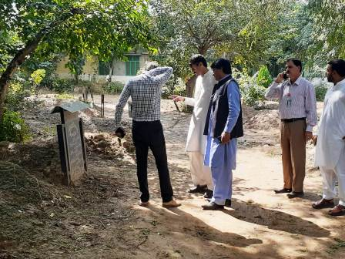 | 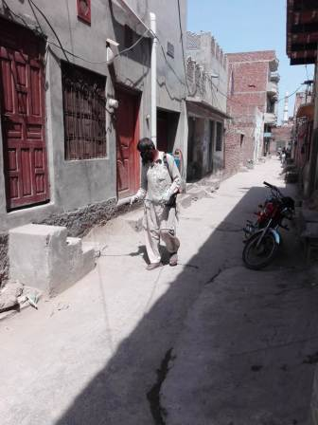  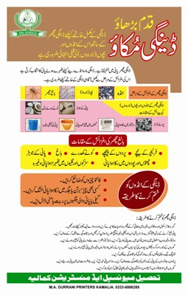
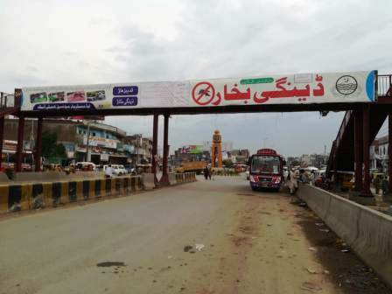 | 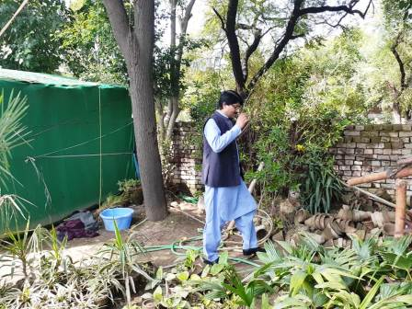

Khidmat Apki Dehleez Per

On the directions of Chief Minister Punjab, Sardar Usman Buzdar, 'Khidmat Apki Dehleez per' program was launched in the Daska City. The basic purpose of the program was to revive government machinery for effective delivery of services. Municipal Committee Daska were also given specific tasks in accordance with the needs of the public to ensure the effectiveness of service delivery mechanisms. The program was truly beneficial for the masses. Weekly schedule was issued in which the officers of municipal committee monitored the sanitation, sewerage and other matters in their allocated areas. The citizens were asked to identify/ highlight the areas that needs quick attention from Government departments, and Government officials will respond to their issues/suggestions. The activities under “Khidmat Apki Dehleez Par” program had been intensified to clean and beautify government buildings as well as parks, intersections and green belts in all areas of the city. Horticultural development was of great importance and for the purpose, MC Daska along with other departments in had taken special measures to beautify the city. The Administrator monitored the activities being conducted under the program Apki Dehleez Par to ensure that there was no delay in the resolution of people’s problems and all targets were achieved well in time.

 | 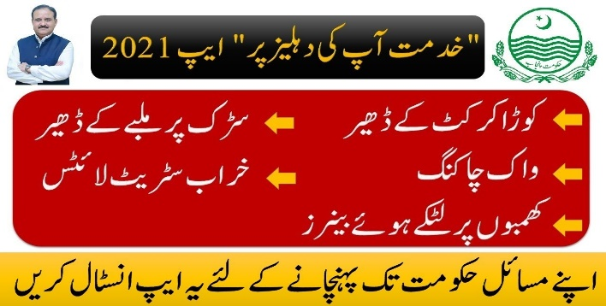
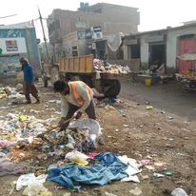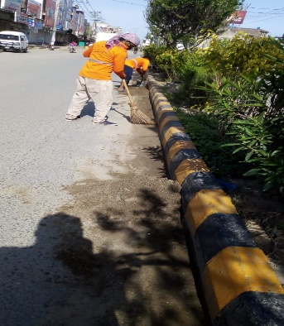 | 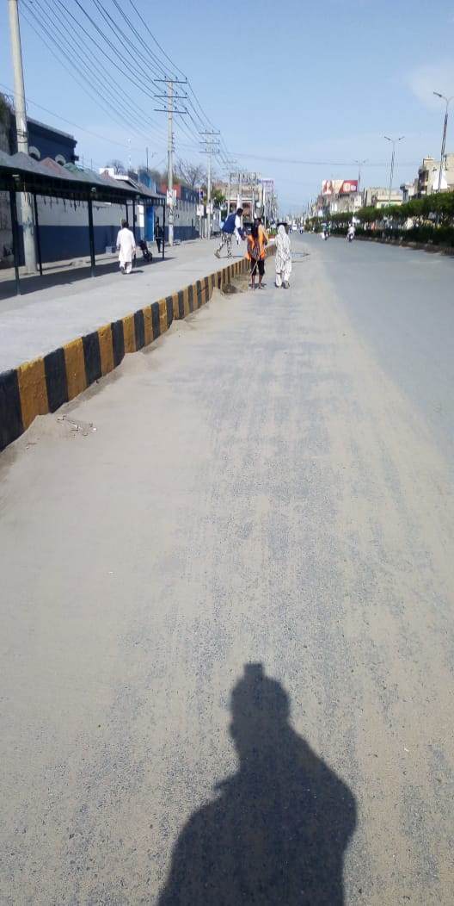
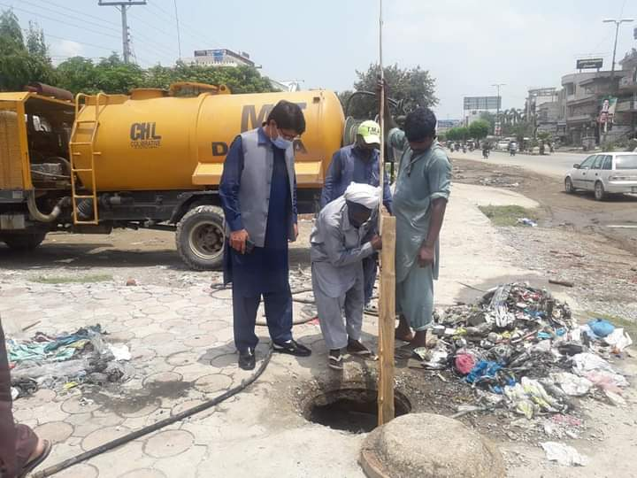 | 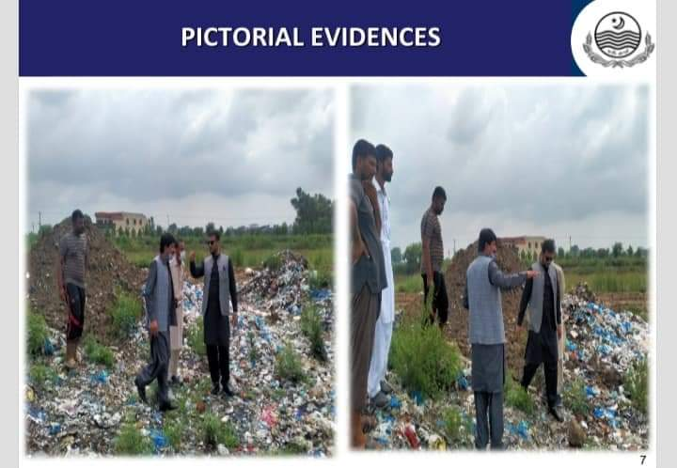

Clean & Green Punjab Campaign

Punjab Government launched an initiative of Clean Green Punjab to make the Punjab clean and green. The Clean Green Punjab campaign included tree plantation, beautification of cities, sanitation, providing safe drinking water, solid waste management and water waste management to its citizens of Municipal Committee Daska. MC took this initiative with full zeal and zest and put its best efforts to turn the city into the clean and green. MC understood that there was a dire need to plant tree to a large extent for ensuring pollution-free environment. MC took practical measures with all financial and human resources. MC also evolved a comprehensive awareness campaign for promoting tree plantation and serious efforts were made in this regard.
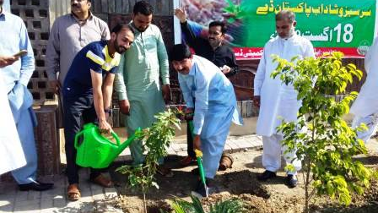 | 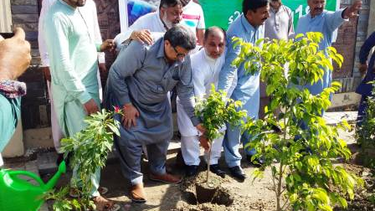
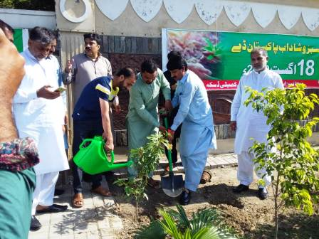 | 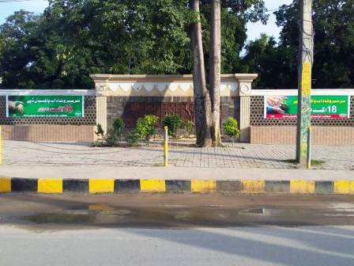
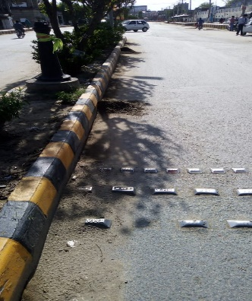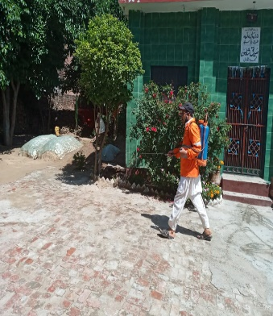

Trainings & Hands-on Sessions

LG&CD Department with the technical assistance of Punjab Municipal Development Fund Company (PMDFC) often organized training programs and hand on sessions for MC management and staff on need basis. PMDFC team always provides continuous support to MCs’ staff for MCs institutional strengthening and capacity building and to enhance performances. Various institutional interventions such as GIS maps, Computerized Financial Management System, Performance Management System, Computerized Complaint Tracking System and MCs’ websites has been developed, implemented and make functional in MC. However, MC management and staff are putting its best efforts for accomplishing the heightened scope of work against these interventions to obtain the subsequent Performance Based Grants (PBGs) against related Performance Measures (PMs) under PCP. In this context, to fulfill the MACs and PMs under PCP, the detail of work has been chalked out and mentioned below:

Sr. No. | Interventions | Detail of Work
1 | GIS Maps | Updated GIS based maps are available with MCs  - Base maps,  - Municipal Infrastructure maps (water supply, sewerage, solid waste, Road hierarchy & streetlight)
2 | Computerized Financial Management System (CFMS) | - Budget Entry for the current financial year  - Cash book entry for the current financial year  - Receipts  - Expenditures
3 | Performance Management System (PMS) | - Reports on Performance Indicators to track status of municipal services i.e. water supply, sanitation and streetlights:  - Expenditures details on various municipal services i.e. water supply, solid waste, street lights as per information provided by MCs  - Customized reporting as per requirement
4 | Computerized Complaint Tracking System (CCTS) | - Registration of complaints in the web based software  - Sector wise (Water Supply, Solid Waste, Street Light, Sewerage System etc) reports  - Different analyses of resolved & unresolved complaints  - Information pertaining complaint registration and resolution time
5 | MC Websites | Update the links on MC website on regular/ need basis  - News & Event  - Notice & Tenders  - Administrative setup (Name of officer, date of joining, qualification, total service, contact No)  - Budget  - Incumbency  - Other website links
Actions accomplished for implementation of the interventions
A. MCs designated the officials to manage the interventions
B. Refresher Trainings.
C. Continuous follow-up by PMDFC
D. MCs managed requisite hardware
E. MC management were sensitized to review systems generated reports on regular basis.

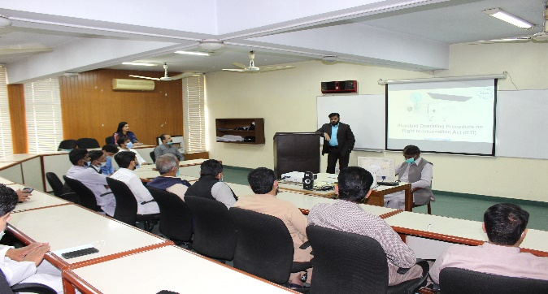 | 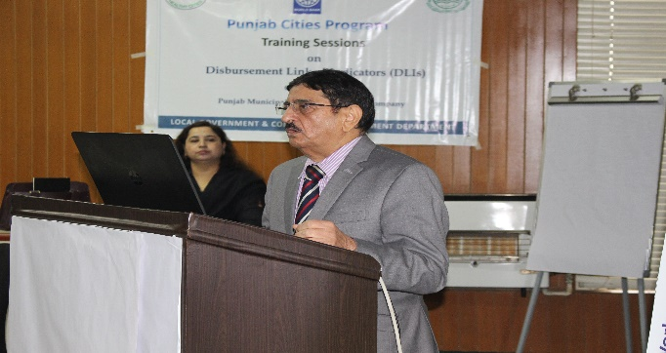
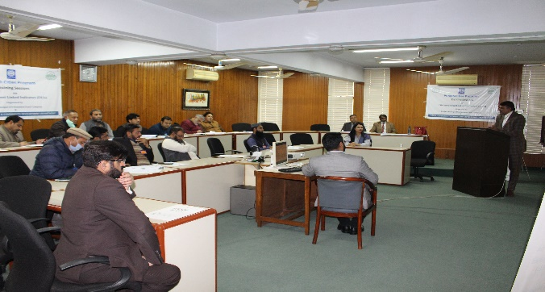 | 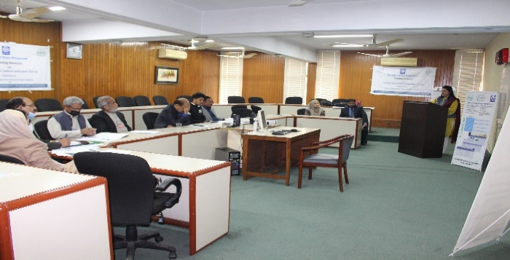
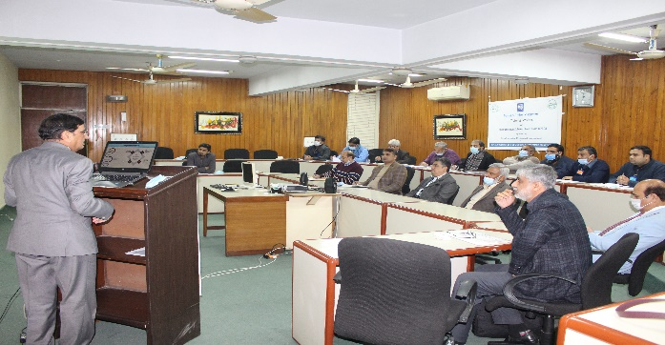 | 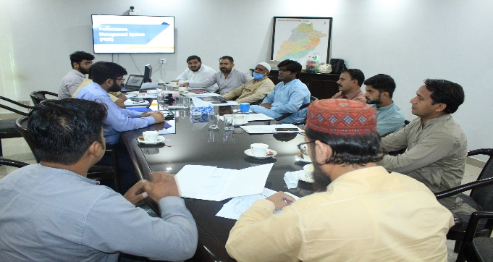
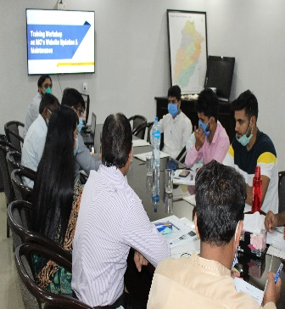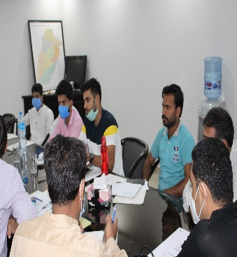 | 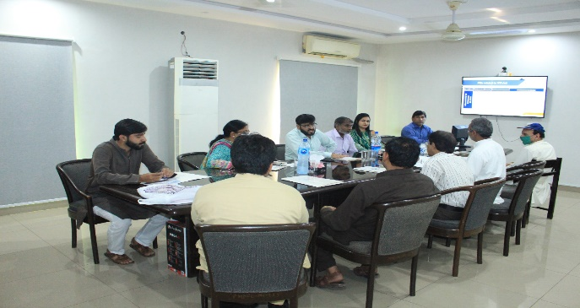

Development Projects under Punjab Cities Program (PCP)
Infrastructure projects completed under Punjab Cities Program is as under:
(Rs. in Million)
Sr.# | Project Name | Project Detail | Duration | Project Cost
1 | Rehabilitation of Municipal Services in Daska City (Group-A) | I-Sewerage  1- Replacement of sullage pumping units  2- Installation of power factor improvement equipment  3- Replacement of penstocks  4- Replacement of bar screens  5- Replacement of sluice valves 12" dia  6- Repair of disposal stations  7- Replacement of 18” i/d, 24” i/d sewer line  II- Street Light  1- Replacement of conventional lights by 120 watt LED lights on main roads  2- Replacement of twin core 7/0.064 copper conductor cable  3- Supply & installation of twin core 7/0.122 Aluminum conductor cable | 6 | 75.152
2 | Rehabilitation of Municipal Services in Daska City (Group-B)  Repair of SWM Machinery | Repair of SWM Machinery  Repair of tractor MF 375 (01 No)  Repair of tractor MF 385 (03 Nos)  Repair of tractor MF 240 (04 Nos)  Repair of arm roll truck  General repair of trolley | 6 | 2.423
3 | Rehabilitation of Municipal Services in Daska City (Group-C)  Replacement of Manhole Covers | I-Sewerage  Replacement of manhole covers along with base frames | 6 | 2.176

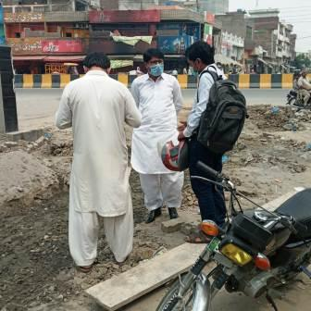 | 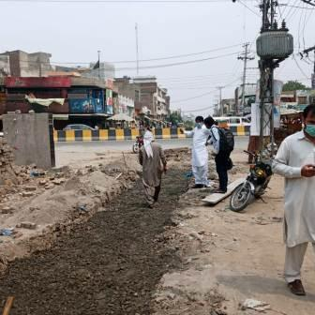
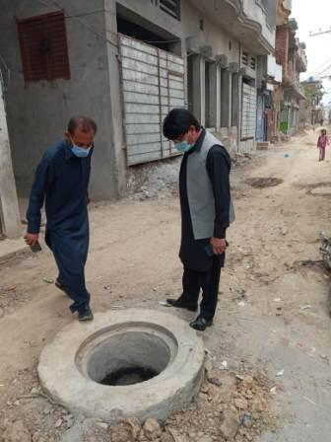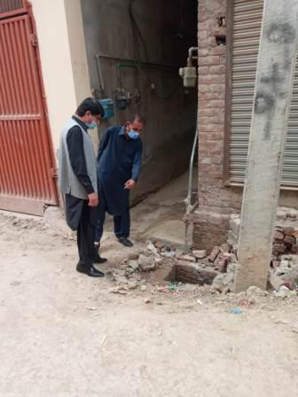 | 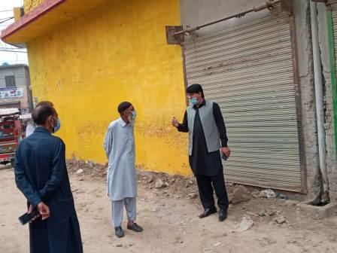

Manpower Deployment
Slot | Sanctioned strength | Existing strength | Vacant post | Manpower on daily wages | Total man power deployed
Tube-well operators | 16 | 14 | 2 | - | 14
Chowkidars | 3 | 3 | - | - | 3
Electricians | 3 | 3 | - | - | 3
Plumbers | 0 | 0 | - | - | 0
Plumber helpers | 2 | 2 | - | - | 2
Water Superintendent | 0 | 0 | - | - | 0
Total | 24 | 22 | 2 | - | 22
The vacant positions of the field staff need to be filled for satisfactory service delivery.

Municipal Services Delivery Detail

Water supply hours and consumer connections
Water is being supplied to the city in the below given timings.
Water Supply hours |  |  |  | Consumer Connections (Nos)
Morning | Midday | Evening | Total | Domestic | Commercial | Industrial | Total
5.0 | 4.0 | 5.0 | 14 | 4747 | 30 | Nil | 4777
Water shortage prevails at remote ends of the distribution system because of unequal distribution of water in the absence of consumer metering.

Tariff rates
The consumer connections are not metered and hence water wastage must be pre dominant over here. The tariff comprises of flat rates not even levied according to the area of houses. The water rates are given below;

Tariff Rates per month
Domestic | Commercial. | Industrial
Rs. 150 | Rs. 500 | Not levied

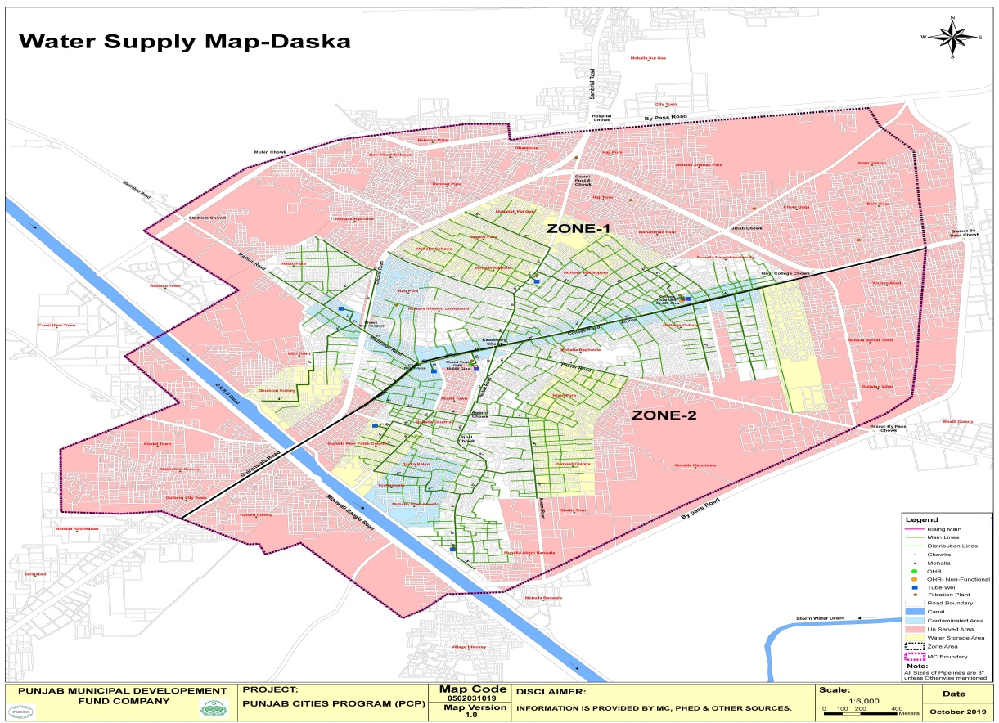

Required rehabilitation of the system
Under mentioned components of the existing system need rehabilitation. Component wise details are given below;

Repair & Replacements of Pumping machinery for Tube wells

Type of Pump | Discharge each (cusec) | Replacement of tube wells | Replacement of pumping units | Repairs of  pumping machinery
Deep well turbine pumps | 1.0 | - | 04 Nos | -

Repair of Pump House:

Water works | Total Nos | Size(Ft.) | Type of repair
Tube wells | 7 | 12’x12’ | Painting and Renovation

Repair of water filtration plants
Total 10 Nos. filtration plants are being maintained by MC in the city, out of which 8 Nos. require repair of certain important component to supply potable water to the inhabitants of the city.

Solid Waste Management

Solid waste Generation & Disposal
The solid waste management efficiency along with present dumping sites is given below;

Solid Waste Generation & Disposal
F.Y. 2020-21
Avg. Generation of Solid Per Month | 2,438 Tons
Avg. Solid Waste disposed of Per Month | 1,659 Tons
% age of Waste Disposed of Per Month  (% Efficiency) | 68%

Equipment & Machinery
Presently available equipment and machinery for collection, transportation and dumping of the solid waste is given below. Some of the existing machinery such as tractor trolleys are not cost effective and efficient giving rise to low efficiency, insanitary conditions and increased waste management cost. Efficient and cost-effective machinery is needed for the entire city to increase the efficiency of collection and transportation for improving the sanitary conditions and lower down the operational and maintenance costs;

S.No | Equipment/Machinery | Total available  Nos | Nos.  Requiring repair
1 | Tractor | 04 | 04
2 | Trolley | 04 | 01
3 | 1.0 m3 containers | 22 | -
4 | Front blade tractors | 02 | 02
5 | Water bowsers | 02 | -
6 | Mechanical sweeper with Tractor | 01 | 01
7 | Front end loaders | 03 | 01
8 | Arm roll truck | 01 | 01

Manpower Deployed and requirement
The manpower deployed for collection, transportation and disposal of the solid waste is shown in the under given table. Due to non-recruitment of the manpower for sewerage system 19 sanitary workers have been deployed on operation & maintenance of the sewerage system which has further reduced the manpower availability for solid waste management. As indicated by MC Officers this man power is not sufficient to serve the entire city at the given standards. Additional man power required by the MC is also been indicated. Actual requirement will be identified after detail design and implementation of the project.

Slot | Sanctioned strength | Existing Regular strength | Vacant slots | Manpower on Daily wages | Total manpower deployed
S. S Inspector | 01 | 01 | - | - | 01
Sanitary Inspector | 02 | - | 02 | - | 0
Tractor Driver | 14 | 03 | 11 | -
Sanitary Supervisor | 04 | 01 | 03 | - | 03
Sanitary Worker | 199 | 154 | 22 | 23 | 177
Operator (Dewatering set) | 3 | 0 | 3 | - | -
Total | 223 | 159 | 41 | 23 | 184

Existing situation

The existing situation of solid waste management is not satisfactory. Most of the city is partially served and complete service is being provided in few areas. The partially served areas are at tended on the complaints of the citizens as regular and daily service cannot be given. Some areas of the city are still not served because of limited’
resources available with MC Daska as explained in the following paragraphs. The details of the partially served and un served areas of the city are given below;

Un-served and Partially Served Areas
Most of the areas of the city remain either un-served or these are partially served. The detail of these areas is given blow.
a) Partially Served Areas
No regular service is rendered in the under mentioned areas. The main complaints are attended by sending the machinery & labor once or twice a week.

1 | Mohallah Mandi wala | 2 | Shafiq town | 3 | Hameed town
4 | Abadi ban wala | 5 | Nazirabad colony | 6 | Khalid town
7 | Canal View town | 8 | Ramzan town | 9 | Qazi town
10 | Gulshan colony | 11 | Habib pura | 12 | Mohallah bijlighar
13 | Rehmat pura | 14 | New abadi Sohawa | 15 | Ganj pura
16 | Haji pura | 17 | Mohallah Shahab  Pura | 18 | Chota Gagga
19 | Bara Gagga | 20 | Younis abad

b) Un served Areas
Under mentioned areas are still not served;

1 | Mohallah Barkat town | 2 | Ghulistan villas | 3 | Village Bhroke
4 | Reham colony | 5 | Gullberg city town | 6 | Rehman pura
7 | City town | 8 | Inam colony | 9 | Mohallah Nadimabad

Solid Waste Generation & Disposal
The solid waste management efficiency along with present dumping sites are given below;
Total waste  generated per day |  | Total waste collected(Tons) |  | % Efficiency of  disposal | Name of dumping sites with distance in Km from the city center
Cubic  meters | Tons | Cubic  meters | Tons |  | Near village Bhobkan wala
144 | 72 | 80 | 42 | 57%
Distance from city center(Km) |  |  |  |  | 12 KM
Open dumping=O Landfill= LF |  |  |  |  | O

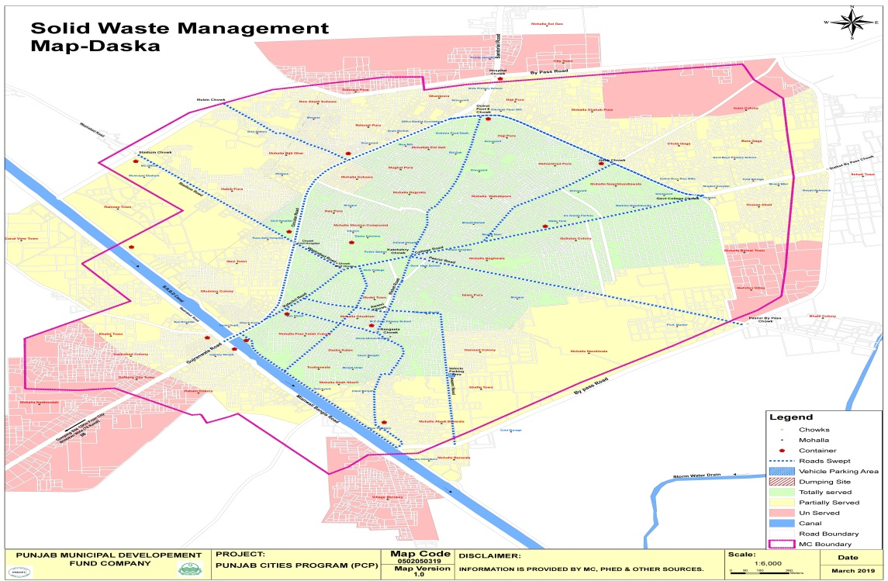

Sewerage

Coverage
- The city has main sewers on approximately 70% area, but lateral sewers are missing in most of the city area. Due to non-provision of lateral sewers, sewerage water is collected though the surface drains and then discharged in to the sewers without gulley grating chambers.
- The sewerage system is equipped with three disposal stations. A new disposal station is included in the PHED proposal on the Awami Road which will replace the existing disposal on this road. The other two disposal works on Pasrur road and Stadium Road need repairs and replacement of machinery & other allied equipment as mentioned in the tables below.
- Gully grating chambers in the entire system are missing, due to which solid waste is being pushed into sewer lines which leads to choking of sewers.
- Waste water is being discharged in the seepage/storm water drains without treatment
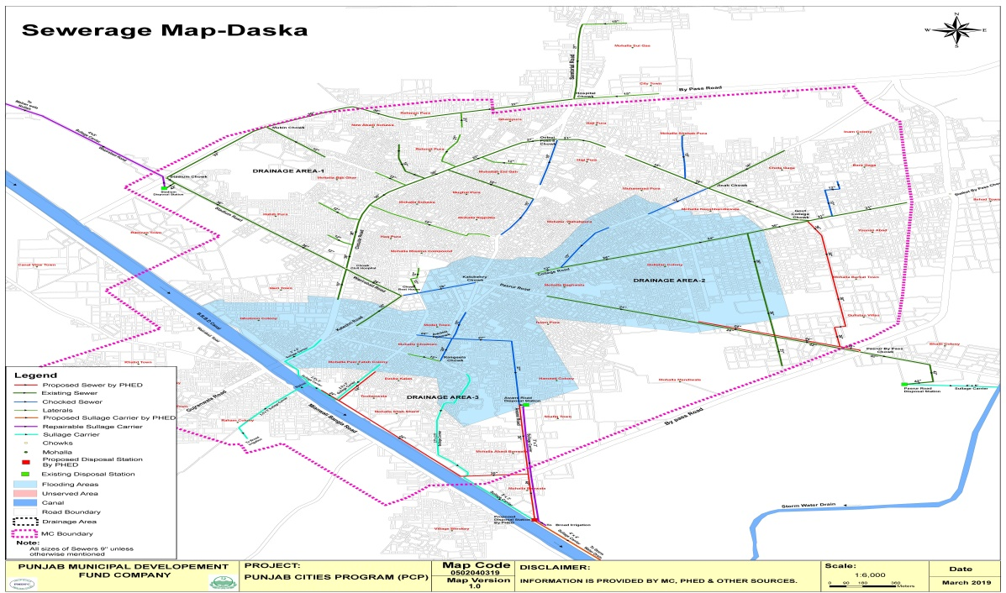

Drainage zones.
The city has been divided in 3 zones in respect of the waste water drainage. Each zone with its coverage is described below;
a)Zone-1
This zone is comprised of areas lying in the north west of the college road. A trunk sewer of 33inchdiametercollectsthe waste water from areas like Rehman pura , New Abadi Sohawa etc. and it joins the36”dia sewer coming from stadium road from the opposite side and then the 42”diameter outfall sewer discharging in stadium disposal works.
Two sewers are choked in this zone which need replacement as marked on the map. Waste water from this disposal works is pumped into a sullage carrier which ultimately discharges in to Malianwala nullah without treatment .In the way the water is also used for broad irrigation.
b)Zone-2
This drainage zone comprises of the eastern part of the city and is drained off in to Pasrur road disposal works.42”dia outfall sewer collects water from a 36” dia sewer from the Muhallah Naqashbandia, Gulistan colony and other areas and also from a 24”size sewer. Three sewers are choked in this zone which need replacement as marked on the map.
The waste water is pumped in to a sullage carrier and ultimately being disposed into Storm water drain without treatment.
Two main sewers first from college road to Pasrur bypass chowk (36”) and the second along Pasrur road (24”) have been included in the PHED proposal as marked on the map
c)Zone-3
This drainage zone comprises of the southern part of the city and is drained off into Awami road disposal works. The 27”dia outfall sewer along most of the other sewers in the system are choked.
The disposal station on the Awami road is in very poor condition which has been proposed to be replaced with a new disposal on Awami road near B.R.B.D canal. However the construction of new disposal station is held up due to non-availability of funds & it is not clear that exactly when it will be completed .So, the rehabilitation of existing disposal works on Awami road by MC is also under consideration. Two new main sewers one along the Awami road (30”& 48”) and the second along the B.R.B.D (24”& 30”) canal have been included in the PHED proposal which will feed the new Awami Road disposal works.
The waste water is pumped in to a sullage carrier and ultimately being disposed to broad irrigation currently but after the construction of new proposed sullage carrier, it will be disposed-offin storm water drain flowing on the south eastern side of the city.
The detail of the ongoing work by PHED is given below in the one page note.
Tariff structure
Sewerage connections are not being charged by MC at the moment as no tariff has been levied by Municipal Committee.
Man power deployed
Presently 11 sanctioned posts of sewer men and10 sanctioned post of pump operators are available in MC but these have not been recruited because of recurrent ban on the new recruitments as informed by the Chief Officer. Only one regular sewer man is available with the MC. Presently 10sanitary workers have been deployed as sewer men and 8 sanitary workers have been deployed as pump operators, along with one chowkidar.
The sanctioned strength of the sewer men is too meager to maintain the sewerage system and that too have not been recruited. Lifting of ban on recruitment is required to employ the staff on 20 regular sanctioned slots

Sewer lengths
The length of old sewers as per information given by the Municipal Committee , are given below; these are approximate lengths and may vary if actually measured at site;

Approximate lengths of existing sewers

Sewer dia.  (inch) | 9 | 12 | 15 | 18 | 21 | 24 | 27 | Total length  In Km
Length in Km | - | 1.3 | 5 | 0.6 | 1.5 | 2 | 2.5
Sewer dia (inch | 30 | 33 | 36 | 42 | 48 | 54 | 66 | 19.2 Km
Length in Km | 1 | 0.8 | 3 | 1.5 | - | - | -

Streetlight
MC Daska has street lights on major roads and Mohallahs

Streetlights on Major roads:
Some roads in the city have been provided with street light. The detail of these installations is given below;

S.N. | Name of Road/Street | Type of luminaries | No. of  Lights | Type of Poles
1 | Stadium Road | LED 120 Watt | 20 | Double Arm Pole
2 | Bank Road | LED 120 Watt | 26 | Double Arm Pole
3 | Kachahri Road | LED 120 Watt | 44 | Double Arm Pole
4 | Collage Road | LED 120 Watt | 60 | Double Arm Pole
5 | Jamakay Road | LED 50 Watt | 15 | WAPDA Pole
6 | Pasrure Road | LED 50 Watt | 17 | WAPDA Pole
7 | Sambrial Road | LED 50 Watt | 20 | WAPDA Pole
8 | Wazirabad Road | LED 50 Watt | 14 | WAPDA Pole

Ward wise detail of existing streetlights
Energy saver bulbs are being used instead of LED lamps which are fulfilling the requirements in different Mohallas.

Ward  No | Area | Energy Saver  24 to 30W | Operational  Status | Poles types  WAPDA pole  /Street light pole
1 | Awami Road | 30 | 17 | WAPDA pole
2 | Waddala Road | 30 | 17 | WAPDA pole
3 | Street Mission compound | 30 | 7 | WAPDA pole
4 | Bazzar thatharan | 30 | 36 | WAPDA pole
5 | Daska kallan Road | 30 | 27 | WAPDA pole
6 | Affshan Road | 30 | 50 | WAPDA pole
7 | Gallah Shaheedan wala | 30 | 20 | WAPDA pole
8 | Sobedar Bazar | 30 | 15 | WAPDA pole
9 | Machli Bazar | 30 | 20 | WAPDA pole
10 | Sabaz mandi | 30 | 25 | WAPDA pole
11 | Daska Kallan bazaar | 30 | 70 | WAPDA pole
12 | Model Town | 30 | 40 | WAPDA pole
 | Total | 360 | 344

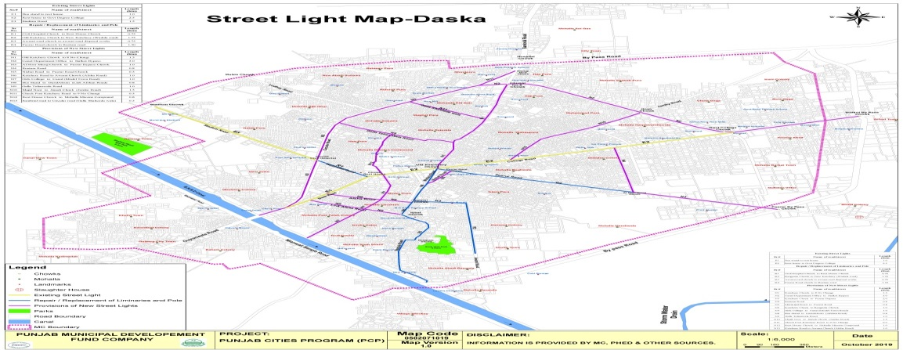

Complaint Management
Municipal Committee Daska has established a centralized complaint cell for complaints registration, its tracking and resolution. The primary objective of establishing complaint cell was to enhance MC’s efficiency in addressing citizens’ and building confidence of citizens.
The complaint cell has been provided with telephone line to facilitate the complaint registration over the phone without walking in to the office. Every complaint, whether received in writing or verbally, is recorded in the software by a designated complaint cell in charge. Each recorded complaint generates a unique number already printed on the complaint slip. The complainant also receives the complaint number for the follow up, if required. Once the complaint is resolved by the relevant staff, he returns his part of the complaint slip to the complaint cell with his remarks and the complaint cell in charge updates the status of complaint in the software accordingly. The complainant may inquire the status of his complaint at any time just by calling the complaint registration office with reference to his complaint number. This process ensures the registration and tracking of all the complaints, thus keeping MC staff accountable to the MC management as well as the citizens.
Complaints: Received Summary Year – 2020-21
Sector | Complaints
Water Supply | 19%
Sewerage and Drainage | 27%
Streetlight | 0%
Solid Waste | 54%
Percentage Received | 100%

MC Website (www.mcDaska.lgpunjab.org.pk)

Municipal Commttee Daska has also developed its website for dissemination of information for general public. The information contains all major categories of information for citizen’s interest like information about the officers with their telephone numbers, budget detail, Development projects, news and events

MC Response to the Requests of Citizens under RTI Act 2013

No request received from any citizen during the current year

Annex-A
Section Name | Name of Post | BPS | Vacancy Detail (Nos.)
 |  |  | Sanctioned | Filled | Vacant
Office of Chairman | Mayor | Fixed | 1 | 0 | 1
 | Assistant | 11 | 1 | 1 | 0
 | Junior Computer Operator | 12 | 1 | 0 | 1
 | Naib Qasid | 1 | 1 | 1 | 0
 | Office Boy | 1 | 1 | 0 | 1
 | Sub Total | - | 5 | 2 | 3
Chief Officer | Chief Officer | 18 | 1 | 1 | 0
 | Office Superintendent | 17 | 1 | 0 | 1
 | Office Assistant | 16 | 1 | 0 | 1
 | Senior Computer Operator | 16 | 1 | 0 | 1
 | Senior Clerk | 14 | 3 | 2 | 1
 | Junior Computer Operator | 12 | 1 | 0 | 1
 | Octori Clerk | 11 | 1 | 1 | 0
 | Junior Clerk | 11 | 1 | 1 | 0
 | Driver | 4 | 1 | 1 | 0
 | Office Boy | 1 | 1 | 0 | 1
 | Naib Qasid | 1 | 1 | 1 | 0
 | Chowkidar | 1 | 1 | 1 | 0
 | Sanitary Worker | 1 | 2 | 0 | 2
 | Sub Total | - | 16 | 8 | 8
Municipal Officer (Regulation) | MO (R) | 18 | 1 | 0 | 1
 | Assistant | 14 | 1 | 1 | 0
 | Senior Clerk | 14 | 1 | 1 | 0
 | Computer Operator | 15 | 1 | 0 | 1
 | Junior Computer Operator | 12 | 2 | 0 | 2
 | Octori Clerk | 11 | 3 | 3 | 0
 | Driver | 4 | 1 | 0 | 1
 | Office Boy | 1 | 10 | 0 | 10
 | Junior Tax Collector | 11 | 3 | 3 | 0
 | Legal Advisor | Fixed | 1 | 1 | 0
 | Sub Total | - | 24 | 9 | 15
Municipal Officer (Finance) | MO (F) | 18 | 1 | 1 | 0
 | Assistant Accountant | 16 | 1 | 1 | 0
 | Senior Clerk | 14 | 2 | 2 | 0
 | Junior Computer Operator | 12 | 2 | 0 | 2
 | Octori Clerk | 11 | 2 | 2 | 0
 | Driver | 4 | 1 | 0 | 1
 | Naib Qasid | 1 | 1 | 1 | 0
 | Naib Qasid | 2 | 1 | 1 | 0
 | Junior Tax Collector | 11 | 9 | 0 | 9
 | Office Boy | 1 | 1 | 0 | 1
 | Sub Total | - | 21 | 8 | 13
Municipal Officer (IT) | M O (IT) | 17 | 1 | 0 | 1
 | Junior Computer Operator | 12 | 1 | 0 | 1
 | Office Boy | 1 | 1 | 0 | 1
 | Sub Total | - | 3 | 0 | 3
Municipal Officer (Planning) | M O (P) | 18 | 1 | 1 | 0
 | Building Inspector | 14 | 2 | 0 | 2
 | Junior Computer Operator | 12 | 1 | 0 | 1
 | Assistant | 16 | 1 | 0 | 1
 | Junior Clerk | 11 | 3 | 3 | 0
 | Driver | 4 | 1 | 0 | 1
 | Office Boy | 1 | 1 | 0 | 1
 | Chowkidar | 1 | 1 | 1 | 0
 | Sub Total | - | 11 | 5 | 6
Municipal Officer (Archt.) | M O (Archt.) | 17 | 1 | 0 | 1
 | Junior Computer Operator | 12 | 1 | 0 | 1
 | Driver | 4 | 1 | 0 | 1
 | Office Boy | 1 | 1 | 0 | 1
 | Sub Total | - | 4 | 0 | 4
Municipal Officer (Infrastructure & Services) | MO (I&S) | 18 | 1 | 1 | 0
 | Sub Engineer | 14 | 2 | 1 | 1
 | Assistant | 16 | 1 | 1 | 0
 | Junior Clerk | 11 | 1 | 1 | 0
 | Octori Clerk | 11 | 1 | 1 | 0
 | Work Mistry | 7 | 1 | 1 | 0
 | Fireman | 7 | 1 | 1 | 0
 | Fireman | 6 | 1 | 1 | 0
 | Baildar | 4 | 2 | 2 | 0
 | Water Carrier | 4 | 4 | 4 | 0
 | Water Carrier | 1 | 1 | 1 | 0
 | Driver | 4 | 1 | 0 | 1
 | Naib Qasid | 3 | 1 | 1 | 0
 | Office Boy | 1 | 1 | 0 | 1
 | Chowkidar | 1 | 1 | 1 | 0
Library Branch | Junior Computer Operator | 12 | 2 | 0 | 2
 | Office Boy | 1 | 1 | 0 | 1
 | Chowkidar | 1 | 1 | 0 | 1
 | Senior Clerk | 14 | 1 | 0 | 1
 | Assistant | 14 | 1 | 1 | 0
 | Junior Computer Operator | 12 | 1 | 0 | 1
 | Tubewell Operator cum Chowkidar | 7 | 1 | 1 | 0
 | Tubewell Operator cum Chowkidar | 6 | 2 | 2 | 0
 | Tubewell Operator cum Chowkidar | 5 | 4 | 4 | 0
 | Tubewell Operator cum Chowkidar | 4 | 1 | 1 | 0
 | Tubewell Operator cum Chowkidar | 3 | 8 | 7 | 1
 | Operator Filtration Plan | 5 | 6 | 0 | 6
 | Plumber | 3 | 2 | 0 | 2
 | Plumber Qulli | 4 | 2 | 2 | 0
Electricity Branch | Light Inspector | 14 | 1 | 0 | 1
 | Electrician | 5 | 3 | 3 | 0
 | Electrician Helper | 1 | 2 | 2 | 0
 | Sanitary Worker | 3 | 7 | 7 | 0
Disposal Work | Disposal Operator | 4 | 1 | 1 | 0
 | Disposal Operator/Chowkidar | 3 | 9 | 0 | 9
 | Sewer Supervisor | 5 | 1 | 0 | 1
 | Sewerman | 1 | 20 | 0 | 20
Garden & Parks | Mali | 4 | 1 | 1 | 0
 | Mali | 1 | 9 | 0 | 9
 | Ground Man | 2 | 3 | 3 | 0
 | Chowkidar | 1 | 1 | 1 | 0
Slaughter House | Superintendent Slaughter House | Fixed | 1 | 1 | 0
 | Junior Computer Operator | 12 | 1 | 0 | 1
 | Chowkidar | 2 | 2 | 2 | 0
Sanitation Branch | Sanitary Inspector | 9 | 2 | 0 | 2
 | Sanitary Supervisor | 5 | 5 | 1 | 4
 | Driver (Tractor) | 7 | 1 | 1 | 0
 | Driver (Tractor) | 4 | 3 | 1 | 2
 | Driver (Sucker) | 4 | 1 | 0 | 1
 | Driver (Jetting) | 4 | 1 | 0 | 1
 | Driver Arm Roll Truck | 4 | 1 | 0 | 1
 | Driver (Water Bouzer) | 4 | 1 | 0 | 1
 | Operator (Dewatering Set) | 1 | 3 | 0 | 3
 | Sanitary Worker | 2 | 2 | 2 | 0
 | Sanitary Worker | 4 | 7 | 7 | 0
 | Sanitary Worker | 3 | 7 | 7 | 0
 | Sanitary Worker | 5 | 2 | 2 | 0
 | Sanitary Worker | 1 | 178 | 137 | 41
 | Sub Total | - | 329 | 214 | 115
Grand Total |  |  | 413 | 246 | 167

